To structures:

1. What’s the design like
   * Don’t think it will apply to extruder very much
   * Whatever is available to us

To extruder:

1. How big is the extruder going to be:

* Been looking at different designs of the printers, types of printing
* Doing basic designs
  + Can do a small module of a 3D printing head that can attach to anything

1. If we were to actually use the arm, would tangling be an issue

* Run the extruder along the arm
* Bowden vs direct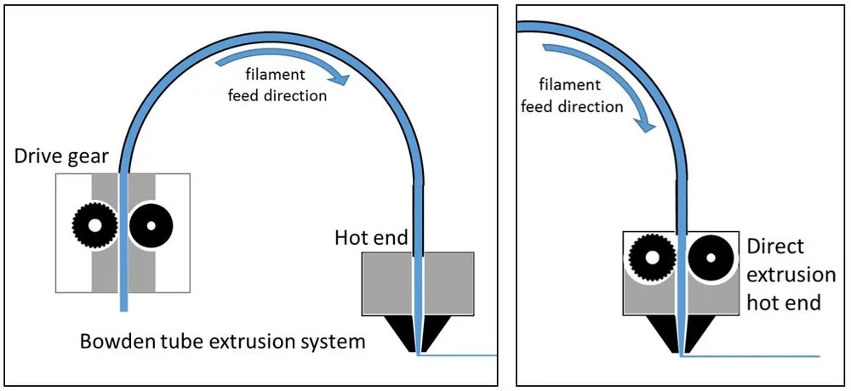

To 3D scanning:

1. Could we use a known dimension instead of spending so long on solving the boundries

* Yes for testing
* But still find ways to solve boundries

1. Scanning small objects

* Scanning small objects with triangulation would result in a lot of air and therefore be in poor resolution

1. Active scanning?

* No
* The scanner would be on a separate system and not build an integration to the printing system

1. Multiple scans?

* That’s what’s used
* We’re just doing the surface scan, not a 3D scan

Sensor Suggestions

* There’s a pobe design where sensors are attached to the end of the probes and letting those probes to sweep over the structure they’re trying to sense.

What extruder is doing:

* Two different designs for extruder, choose whichever depending on what structure is used for the actual robotic arm
* Using PLA for the material
  + Cheapest
  + Most versatile
  + 3mm or 1.75mm

Methodology:

* Write what approach we’re planning on taking this project
* Usually, we could write it based on how much we can do everything in what time frame, but because we still don’t know how long the arms gonna take, just include everything.